Get Ready for Screen-Free Week with these great books!
This year, Children’s Book Week, the annual celebration of books and reading, is the same week as Screen-Free Week! Reading is one of the best ways to go screen-free. Check out this books before Screen-Free Week to get inspired—and then read them again during (and after!) as a reminder that kids of all ages benefit from time to play, unwind, be bored, and connect with family, friends, and nature.

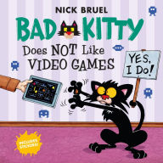
Bad Kitty Does Not Like Video Games by Nick Bruel (Roaring Brook Press/Macmillan Children’s Publishing Group)
Kitty has been playing her video game for FIVE hours. Now it's time for Kitty to: go outside, draw a picture, read a book, do anything other than play video games. She discovers there are many more ways to have fun! (Ages 2-5)
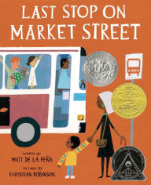
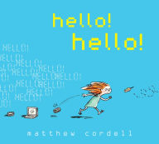
hello! hello!
By Matthew Cordell (Disney-Hyperion)
Lydia says hello to everyone, but her family members are absorbed in their gadgets. Felling restless, she ventures outside where there are so many things to say hello to—rocks, leaves, flowers and more. (Ages 2-6)
Last Stop on Market Street
By Matt De La Pena (Penguin Young Readers)
Every Sunday CJ and his grandma ride the bus across town. CJ wonders why they don't own a car like his friend Colby. Why doesn’t he have an iPod like the boys on the bus? Grandma helps him see the beauty—and fun—in their own routine and the world around them. Newbury and Caldecott winner. (Ages 3-5)
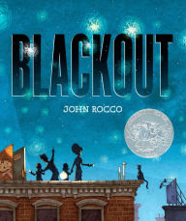
Blackout
by John Rocco (Disney-Hyperion)
A young boy in this book also discovers the simple joys of spending time with loved ones when the city goes dark and there’s no TV. (Ages 4-8)

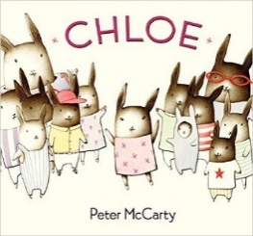
Chloe
by Peter McCarty (HarperCollins Children’s Books)
When a large television takes over family fun time, Chloe must convince her parents and 10 brothers and sisters what every toddler knows: the packaging-- bubble wrap and cardboard box-- is much more fun that the gift--the tv! (Ages 4-8)
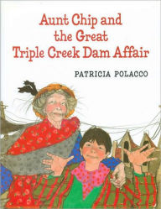
Aunt Chip and the Great Triple Creek Dam Affair
by Patricia Polaco (Penguin Young Readers)
This is a story of how an entire town forgot how to read because they became so addicted to TV. Leave it the town librarian (who is considered a real nut case) to save the day. She inspires one person, her nephew, and through his actions the entire town is once again reminded of the importance of reading. (Ages 5-8)

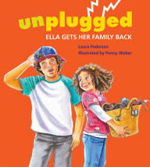
Unplugged: Ella Gets Her Family Back
By Laura Pederson (Tilbury House)
Ella is really frustrated. Lately it seems like the whole family has forgotten how to be together. Instead of playing Hangman and making waffles, everyone is talking on cell phones, playing video games, and using the computer. What’s a girl to do? (Ages 5-8)
Doug Unplugged
by Dan Yaccarino (Dragonfly Books/Random House Children’s Books)
Doug is a robot. His parents want him to be smart, so each morning they plug him in and start the information download. After a morning learning facts about the city, Doug suspects he could learn more by going outside and exploring it. And so Doug . . . unplugs! See also Doug Unplugged on the Farm. (Ages 5-9)
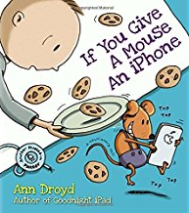
If You Give a Mouse an iPhone: A Cautionary Tail
By Ann Droyd (Blue Rider Press/Penguin Group USA)
If you give in to temptation and give a bored little mouse your iPhone, even for ten minutes, he’s probably going to beam to some faraway place beyond time, space, and the sound of your pleading voice. And if he’s that far gone, he won’t have any idea what’s going on around him, and he might end up missing out on all the real fun. (All ages!)
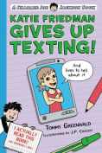
Katie Friedman Gives Up Texting!
by Tommy Greenwald (Roaring Brook Press/Macmillan Children’s Publishing Group)
When a text goes wrong, Katie Friedman learns the hard way that sometimes you need to disconnect to connect. (Ages 9-12)

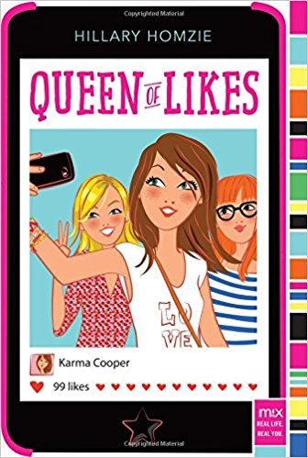
Queen of Likes
by Hillary Homzie (Aladdin/Simon & Schuster Children’s Publishing)
Karma Cooper is a seventh grader with thousands of followers on SnappyPic. Before Karma became a social media celebrity, she wasn’t part of the in-crowd at Merton Middle School. But thanks to one serendipitous photo, Karma has become a very popular poster on SnappyPic. Read what happens when the social media queen is forced to give up her iPhone. (Ages 9-13)

Unplugged
by Donna Freitas (HarperTeen/HarperCollins Children’s Books)
Humanity is split into a dying physical world for the poor and an extravagant virtual world for the wealthy. Years ago, Skylar Cruz crossed over to the App World for a chance at a better life, and her family stayed behind in the Real World. Now Skye is a virtual teenager, surrounded by glamorous apps and expensive downloads—yet she’s never felt like she fits in, and all she wants is to see her mother and sister again. (Teens)

