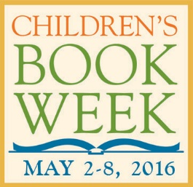

Children’s Book Week Book Drive

Bookstores are encouraged to collect book donations in celebration of Children’s Book Week, the annual celebration of books for young people and the joy of reading. Stores may wish to partner with their own community literacy organization, or either of the following suggested national organizations:

- Reach Out and Read is a nonprofit organization that gives young children a foundation for success by incorporating books into pediatric care and encouraging families to read aloud together.

With program sites all across the country, Reach Out and Read serves nearly 4.5 million children and their families annually by integrating early literacy into pediatric practice as recommended by the American Academy of Pediatrics, equipping parents with the tools and knowledge to prepare their children for early success in school.

Bookstores wishing to collect book drive purchases on behalf of Reach Out and Read can locate the nearest program site that accepts book donations by using the Find a Program locator on the Reach Out and Read website: http://www.reachoutandread.org/resource-center/find-a-program

- Operation Paperback is a non-profit organization founded in 1999 that coordinates book donations to soldiers and families of soldiers to help give military families and children access to books.

To register to donate, please visit http://www.operationpaperback.org/help_register.php ​After registering, reach out to Marisa Falbo (marisa@operationpaperback.org) to let her know your donation is in conjunction with Children’s Book Week; she will help with any questions you have throughout the process. Booksellers can volunteer to run a book drive through their store however works best during Children’s Book Week. Once the drive has ended, you can login and request addresses of veterans or military families using Operation Paperback’s automated system. Input the genres you have on hand, and you will receive a customized list of names for your use. Pack and address your box using the names provided, then head to the post office to mail your box.

Please note that for this donation, bookstores are required to cover the shipping cost. Ask for Media Mail rates to keep the costs to a minimum. Military personnel, veterans, and military families certainly appreciate the time and care given to packaging boxes of books for them.

We would love to hear more about your Book Drive. Go to http://goo.gl/forms/XQkAiWDarw and tell us how it went!

